Sharepoint Ga Release Notes
Release Date: (Pending end of Feb)
Release Version: V1
Availability: Early Access

Overview
The SpecterX SharePoint Connector enables organizations to securely share files externally directly from SharePoint while maintaining persistent file-level control, auditability, and governance beyond the Microsoft tenant.
SpecterX integrates directly into SharePoint workflows, allowing users to provision secure external access without relying on native guest links or distributing unmanaged file copies. Files remain stored within the organization’s SharePoint tenant, while SpecterX governs access, visibility, and enforcement according to organizational policy and data sensitivity. By implementing the SpecterX Sharepoint Connector, organizations can enable external collaboration confidently, while ensuring shared data remains protected and controlled throughout its lifecycle.

Secure External Sharing from SharePoint
Users can now share SharePoint files externally through SpecterX using familiar SharePoint workflows. SpecterX provisions secure, policy-governed access automatically, ensuring external sharing aligns with organizational security requirements without requiring additional administrative involvement.
External recipients are granted controlled access to the file through SpecterX, allowing collaboration while maintaining organizational governance over how and when files may be accessed.
High Level Value
- Allows users to securely share files directly from within Sharepoint
- Eliminates reliance on unmanaged SharePoint guest links
- Enables secure external collaboration aligned with organizational policy
- Automatically enforces access controls based on file sensitivity and share context
- Provides audit visibility into external file access and activity

Live Access Architecture and Governance Model
The SpecterX SharePoint Connector provides governed external access while the file remains stored within the organization’s SharePoint tenant.
Rather than copying or exporting files for external distribution, SpecterX bridges access to the live file stored in SharePoint. This ensures that:
- The SharePoint file remains the single source of truth
- Changes made to the file within SharePoint are immediately reflected to external recipients with continued authorized access
- External access is granted through SpecterX-managed controls, not native guest permissions
- Access remains governed and auditable, and may be automatically restricted, expired, or revoked based on organizational policy or user action
This architecture enables secure collaboration without creating unmanaged external file copies, while extending file-level governance beyond the tenant boundary.

Native SharePoint User Experience
The SpecterX Connector integrates directly into the SharePoint interface, allowing users to securely share files without leaving their existing workflow.
Sharing through SpecterX mirrors familiar SharePoint sharing actions, enabling users to collaborate externally while SpecterX transparently applies governance and access controls in the background.
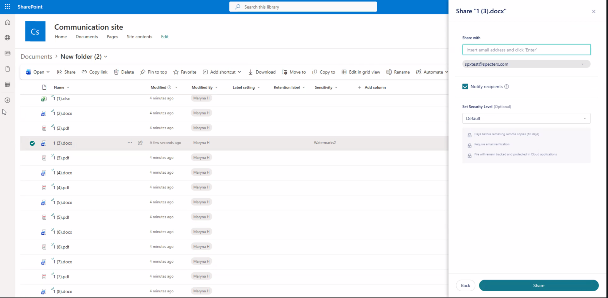
User guidance and deployment documentation will be provided at General Availability.

Administrative Deployment Controls
Administrators maintain full control over how and where the SpecterX Connector is deployed within the SharePoint environment.
Deployment may be scoped by:
User scope
- Enable for all licensed users, or
- Restrict to specific pilot groups or security groups
Site scope
- Deploy across the entire SharePoint tenant, or
- Restrict to specific SharePoint sites or site collections
This allows organizations to align deployment with their operational and security rollout strategy. Further documentation for admin deployment and management will be provided at GA release.

